MSCA
A European Approach to artificial intelligence ( https://digital-strategy.ec.europa.eu/en/policies/european-approach-artificial-intelligence),
the EU Digital Finance Package (https://finance.ec.europa.eu/publications/digital-finance-package_en)
https://digital-strategy.ec.europa.eu/en/policies/strategy-data
https://sdgs.un.org/goals
WEF 2020, https://www3.weforum.org/docs/WEF_AI_in_Financial_Services_Survey.pdf
https://sdgs.un.org/goals
https://ec.europa.eu/info/sites/default/files/commission-white-paper-artificial-intelligence-feb2020_en.pdf
https://digital-strategy.ec.europa.eu/en/policies/blockchain-strategy
https://ec.europa.eu/info/strategy/priorities-2019-2024/european-green-deal_en
https://op.europa.eu/en/publication-detail/-/publication/bb02d56e-9b3c-11eb-b8501aa75ed71a1/language-en
https://www.eeas.europa.eu/sites/default/files/horizon_europe_strategic_plan_2021-2024.pdf
https://digital-strategy.ec.europa.eu/en/policies/digital-skills-and-jobs

Innosuisse
Machine Learning (ML) allows creditors to reduce lending risk by evaluating an abundance of customer data. However, these models lack the transparency required by regulators. We propose a visual analytics tool for understanding the inner-workings of ML models as they apply to credit scoring.

Swiss financial intermediaries are falling behind in using alternative data and novel Artificial Intelligence (AI)-driven credit scoring methodologies. Partially, this is due to the large legacy IT landscape which might not be accommodating for advanced analytics. An even more relevant barrier for wider adoption of AI in the context of the Swiss finance sector is related to the concept of explainability. Namely, AI solutions are often referred to as “black boxes” because typically it is difficult to trace the steps the algorithms took to arrive at its solution and understand how they have made their decisions. This challenge is particularly relevant for Swiss financial intermediaries: both traditional and FinTech companies face similar challenges in adhering to data-related regulations such as the General Data Protection Regulation (GDPR) which provides a “right
to explanation”, enabling users to ask for an explanation as to the decision-making processes affecting them. This impacts their ability to develop AI-based solutions.

We propose building a visual analytics (VA) tool, specifically tailored to the context of credit risk evaluation, useable for both model developers (i.e. Swiss financial intermediaries operating in the commercial or consumer credit space) as well as model evaluators (Swiss regulatory bodies that have to validate the models). More importantly, such a visual tool will enable model evaluators, a non-technical audience, to gain some insight into how AI models applied to credit scoring work and identify the reasons behind the decisions taken.
The proposal of this innovation project is to develop a VA tool that will be used both by model developers (Swiss financial institutions) and model evaluators (Swiss regulators) for the purpose of understanding the inner-workings of AI/ML techniques applied to credit scoring. The VA tool will enable users to manipulate the input features and/or model specifications, and observe the resulting change in the outputs of the model (Figure 1).
The Business Side. One use of the proposed VA tool will be in the context of Swiss financial institutions developing credit scoring methodologies (i.e. large Swiss banks as well as FinTech credit providers such
as Cashare, CreditGate24, Crowd4Cash, Lend, Invest I2 etc.). In most cases, these companies are familiar with building and developing ML models but might be interested in improving such techniques by running quality checks on an existing platform.

The Regulatory Side. The second use case of our proposed VA tool is that of a national regulator reviewing a FinTech lender’s business model. In this context, the regulators need to review the internal credit risk ML-based model to avoid potential weaknesses of a naive application of ML. Being, in most cases, non-experts in ML, regulators need an easy-to-use tool that will allow them to answer the following questions: is the model mimicking the decision-making process of a financial expert or at least responding “rationally” to sets of inputs? Is it “too” sensitive to small changes of the input features? What are potential operational risk issues arising from the model?

Describe the novelty of the solution (technology, product, business model or process, service).
We propose building a VA framework (Figure 2) that will enable users to manipulate the input features of a specific problem task and observe the resulting change in the outputs of the model. As an end result, the tool will provide a positive or negative score concerning the following aspects of the model performance:

- “In line with financial logic” → The tool will enable users to identify the main features that drive the model’s outputs and obtain an overall score of whether the model is choosing factors that would be selected by a financial expert i.e. whether the specification is in line with financial logic.

Robust classification of risk classes
  - The tool will enable the users to understand how sensitive the model is to slight changes in input features and provide a score on the overall influence of each input factor on output variations in a specified model.
  - The tool will also enable users to investigate how sensitive the machine learning models are to small changes in data, using original, domain-specific adversarial attack.

Technical robustness
  - The tool will provide a high-level quality score measuring the run-time robustness of the model with regard to scalability, error-handling, &c.
  - The tool will assess the model’s robustness with regard to (technical) data quality and its ability to consistently deal with, e.g. missing data, erroneous data, data inconsistencies, &c.

Operational risk impact
  - The tool will identify the potential Operational Risk impact of the model under consideration, provide a risk matrix indication, identify critical issues, and suggest necessary mitigations. The OpRisk VA will be placed in the context of OpRisk management / ERM, proposing an additional layer of scrutiny with regard to model risks &c.

In addition to the high-level scores of the overall performance of the model in terms of its financial sense and robustness, the tool will also allow users to drill down to any level of detail in order to obtain a detailed view of the comparative changes in outputs due to individual manipulations of the input features. This will be enabled both though integrated options within the VA tool or through open source materials (eg. open- source code - R package and documentation) made available on the project's website
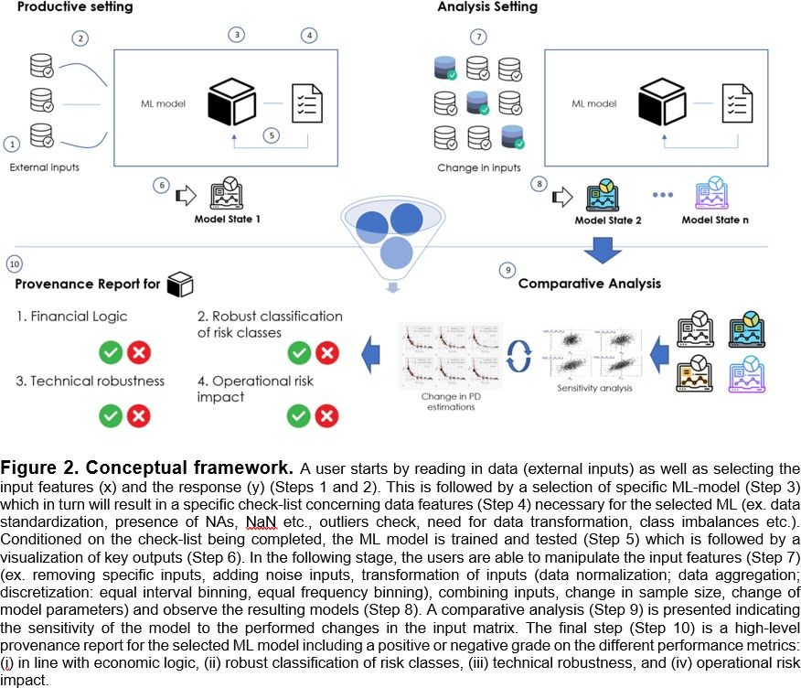 What is innovative about the solution? The novelties associated with the VA tool proposed are many- fold. First, as suggested previously, to the best of our knowledge, none of the existing XAI methods available on the market are specifically tailored to financial experts. The solution outlined in this proposal will be context-specific and customized for credit scoring tasks i.e. input manipulation and output visualization will be completely tailored to financial experts’ needs. Second, the majority of existing solutions require some level of technical expertise for the use of the XAI method. This in turn excludes model evaluators (regulators and supervisors) which in most part are a non-technical audience. In this context, the VA tool will have a high-level functionality i.e. summing up and aggregating the complexity of the ML project in an easy-to-understand report of the overall quality and robustness of the model. This will also allow non-experts to quickly grasp key properties of the model in relation to financial logic and robustness. This being said, the VA tool will also have a technical functionality, suggesting that a ML- knowledgeable audience will be able to drill down and check all technical details and complexities of the modelling. Having this structure, we expend the stakeholder group to both model evaluators and model developers. Third, the proposed VA tool will be developed based on cross-field expertise and a user study. Namely, in order to verify the intuitiveness of the workflow as well as the usability of the VA framework, we

will conduct a qualitative user study with the different user types and use the feedback obtained to further develop the tool.

Describe the state of science and technology that you intend to advance.
A variety of explainable Artificial Intelligence (XAI) methods are available in the literature. However, the majority of them are model-specific, meaning that they are valid only for a specific ML model. In the context of our proposed tool, the VA framework will be built as a model-agnostic framework, thus it will be indifferent to the selected ML model. This being said, there are solutions available in the literature that, similar to the proposed methodology, are model-agnostic. One of the most popular methods in this context is the Local Interpretable Model-Agnostic Explanations (LIME). This method uses the models’ output on a data sample to generate a linear surrogate model that explains the feature importance. This solution works alongside existing classifiers to provide explanations for the classifiers’ predictions in a way that in addition to being model agnostic, it is also locally faithful (Mueller and Klein, 2019).

One limitation of LIME and other available techniques is that they are context-agnostics. In most cases, the necessary manipulations to the dataset are greatly dependent on the specific context for which model interpretability is required. This in turn means that general tools might lead to suboptimal results in most contexts i.e. would not lead to high interpretability of results. A VA tool tailored to the credit risk task in general and the needs of model evaluators, in particular, is currently lacking in the XAI method literature.

Furthermore, the majority of XAI methods available are not suited for a non-technical audience. In the context of LIME and MAPLE, these are open-source libraries that can be used to help model explainability however, they cannot be used without a working knowledge of open source programming language such as Python. The situation is similar with explAIner, which is another example of an existing framework for interactive and explainable machine learning that enables model users and model developers to understand machine learning techniques and work on improving them. The VA tool in this context is operationalized as a TensorBoard plugin hence this solution too, requires technical knowledge and is not tailored to financial experts. Yet another example of a VA tool available is that by IBM - AI Explanbility 360 which is an extendable open source toolkit helping different users understand how ML models classify particular labels by various means throughout the AI application lifecycle. In this case too, the toolkit is operationalized as a Python package, thus requiring working knowledge of open source programming language

Provide the quantifiable goals to reach.
In the context of the goals that we intend to achieve with this innovation project, we can make a clear distinction between scientific and technical goals.

In terms of the scientific goals we will:
- Define checklists for the data preparation process necessary for different ML models used for the tasks of credit scoring;
- Define scores for feature importance (i.e. explanations that specify the relative contribution of each input to prediction of a specific risk class) under different ML models used for the task of credit scoring;
- Define choices for input manipulation (including but not limited to: removing specifics inputs, adding noise inputs i.e. adding random variables, transformation of inputs such as data normalization; data aggregation; discretization: equal interval binning, equal frequency binning; combining inputs);
- Define choices for manipulating model specification (including but not limited to: training vs testing sample division, k-folds, seed specifications, hyperparameter setting, choice of optimization algorithm, choice of model architecture);
- Define scores for model sensitivity to changes in: (i) input features and (ii) model specification;
- Define visual representations that will be summarize the overall performance of the model.

In the context of technical goals, we intend to develop a new open-source R package that will:
- Automatize the data preparation process based on a selected ML model used for the task of credit scoring;
- Be fast in training and testing the models;
- Build new (or adapt existing) functions that will extract variable importance and feature interactions leading to explainable models.

Furthermore, for the prototype development, we will build an R Shiny App that will allow users to:
- Input their datasets;
- Run specific ML models;
- Change the input matrix;
- Obtain a report on the various aspects of the model’s performance (i.e. “in line with financial logic”, robustness of model and solution and operational risk impact).
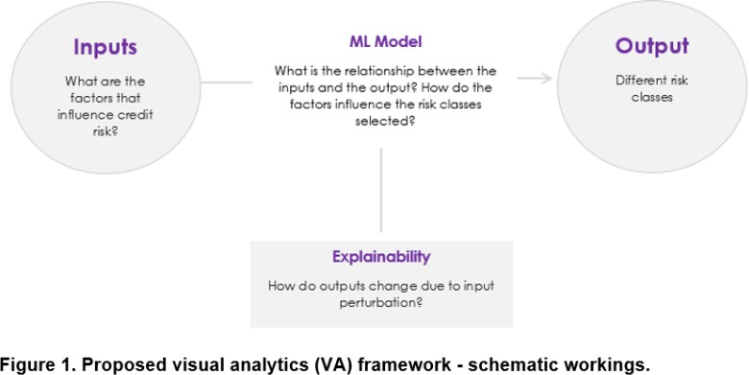

SNF NSF

1. Summary of research plan
Background and Rationale: Artificial intelligence (AI) is creating one of the biggest revolutions across technology driven application fields. For the finance sector, it offers many opportunities for significant market innovation (Dingli and Fournier, 2017, Di Persio and Honchar, 2017, Sen and Mehtab, 2021, Yang, 2021, Shi et al., 2022) and yet broad adoption of AI systems heavily relies on our trust in their outputs (Madabu et al., 2022). To this end, the concept of eXplainable AI (XAI) emerged introducing a suite of techniques attempting to explain to users how the model arrived at a certain decision. Despite the growing popularity of the topic and the large literature, research on XAI in finance remains limited thus there exists a significant gap between deploying explainability in theory and practice.
Overall Objectives and Specific Aims: The project will aim to develop and deploy domain-driven XAI solutions for the finance sector by solving some of the key challenges of deploying explainability to machine learning (ML) and deep learning (DL) models applied to financial use cases. Specifically, the proposal will focus on the following research questions:
- What are the requirements of fairness for different types of financial data? How can we build a metric for fairness that is valid across different financial use cases and what is the best way to communicate the fairness dimension of data quality to different audiences in the finance sector?
- How can we solve the various challenges of deploying explainability in the context of high-dimensional financial input space? How can we build methods that can bring explanations to ML and DL models applied in finance that are easily scalable and can work under the assumption that input features are correlated?
- How stable and robust are explanations provided by state of art XAI methods? How can we build a stability framework that enables different audiences to have an intuitive understanding of robustness of explanations provided by explainability models?
- How suitable are existing XAI methods for bringing explainability to the different stakeholders within the financial value chain (model developers, risk experts, model auditors, and end users)? What type of visualizations are needed to bring an acceptable level of explainability to the different stakeholders in finance?
Expected Results and Impact: The expected outcomes of this research are domain-specific XAI solutions for the finance sector and guidelines for deploying XAI in other industries. Our goal is to better inform science, practice, and policy about this topic by tackling the existing challenges in deploying explainability head-on via several innovative research directions. The impact of the proposed solution can be measured in terms of its contribution to the literature, its potential to improve decision-making processes in finance, and its broader societal implications.
2. Research plan
2.1. Current state of research in the field
2.1.1. Which previous insights provided the starting point and basis for the planned studies?
Many empirical studies provide evidence of the various advantages AI can bring to the financial sector among which enhancing customer experience (Bhattacharya and Sinham, 2022), democratizing financial services (Athey, 2019, Bazarbash, 2019, Sadok et al., 2022) improving consumer protection (Alzahrani and Aljabri, 2022, Aslam et al., 2022) and significantly improving risk management (Guidici, Hadji Misheva and Spelta, 2020, Ahelegbey, Guidici and Hadji Misheva, 2019, Danielsson et al., 2022). Thus, a strong AI-focus will undoubtedly enable finance service providers to thrive in a rapidly digitized and data-driven world. Yet, in practice, financial intermediaries are somewhat behind the curve in comprehensively adopting AI-based systems and tools in their day-to-day operations (WEF Report, 2020). This comes, in part, as a result of the large legacy IT landscape which might not be accommodating for advanced analytics. Another highly relevant barrier for wider adoption of AI in the context of the financial sector is related to the concept of explainability. Namely, AI solutions are often referred to as “black boxes” because typically it is difficult to trace the steps the algorithms took to arrive at its solution and understand how they have made their decisions (Doshi-Velez and Kim, 2017, Miller, 2018, Moscatelli et al., 2019, Cascarino et al., 2022). This reduced ability to understand the inner workings and mechanisms of complex models inevitably affects their trustworthiness and the willingness among practitioners to deploy such methods in sensitive domains such as finance.
As a result, the scientific interest in the field of eXplainable artificial intelligence (XAI) had grown tremendously within the last few years (Adadi et al., 2018, Gunning et al., 2019, Linardatos et al., 2021, Dazeley et al., 2021 and Saeed and Omlin, 2023) and this field of study represents a starting point for the research objectives outlined in this application. Generally speaking, the field of XAI aims at introducing a suite of techniques attempting to explain the inner-workings of complex models (Arrieta et al., 2019). Historically, this need for interpretability and transparency dates back from the early works of expert systems and Bayesian networks (Saeed and Omlin, 2023). However, once complex ML and DL models started to outperform classical methods in applied use cases and forecasting competitions (Makridakis et al., 2020 and 2021, Haselbeck et al., 2022), the XAI field emerged as a thriving research area. Every year, a large number of studies are published that introduce processes and guidelines that would allow users to comprehend and trust the outputs created by ML and DL algorithms (Montavon et al., 2018, Mittelstadt, 2019, O’Sullivan, 2019, Pearl, 2019). At the same time, various studies have attempted to operationalize those guidelines and propose methods that can bring explanations to users (Ribeiro et al., 2016, Montavon et al., 2017, Ribeiro et al., 2018, Lundberg and Lee., 2017, Lundberg et al., 2018 and 2020, Kauffmann et al., 2019, Luo, 2020, Montavon et al., 2022, Kole et al., 2022). In general, these methods are classified in view of four main criteria (Linardatos et al., 2021): (i) the type of algorithm on which they can be applied (where we distinguish between model-specific and model-agnostic XAI methods); (ii) the unit being explained (if the method provides an explanation which is instance-specific then this is a local explainability technique and if the method attempts to explains the behavior of the entire model, then this is a global explainability technique), (iii) the data types (tabular vs text vs images-specific XAI methods), and (iv) the purpose of explainability (ex. XAI methods that test sensitivities or improve model performance, etc.). The most popular XAI methods are discussed in more detail in Section 2.1.2.2. The growing popularity of the topic notwithstanding, research on XAI in finance remains limited and most of the existing explainability techniques are not specifically tailored to the unique properties of financial data. Hence, the existing literature cannot answer how to ensure trust and transparency in AI-based techniques when applied in finance and, thus, fails to deliver theoretically and practically relevant implications. The extensive review of the current state of the research in the field has revealed several challenges and potential research directions which if addressed will be able to push forward for a wider adoption of sophisticated methods in finance. The greater the trust in AI, the more finance service providers will deploy it.
2.1.2. Areas in which research is needed and why?
At the heart of this research proposal lies the goal to provide a deeper, theory-driven, and practically relevant understanding of how to bring trust and explainability to complex, AI-based systems applied to financial use cases. In order to place the XAI challenges in a meaningful way, the research directions are put in context of the distinct phases in a ML pipeline (Figure 1).
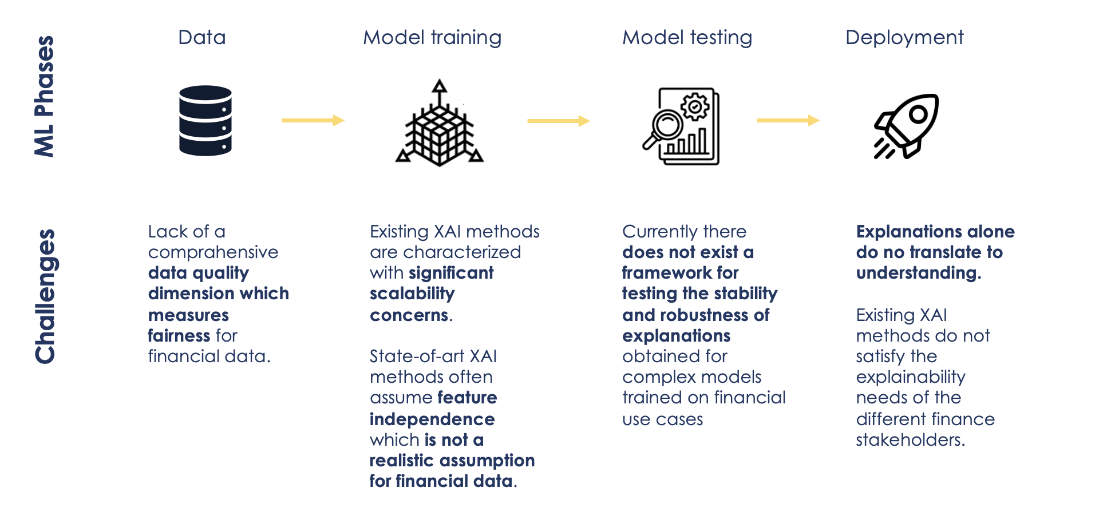
Figure 1. High level overview of the different XAI challenges linked to the different stages of a ML
framework which the project team will address
Generally speaking, every ML process involves four phases: (i) data collection, processing and feature selection, (ii) model training, (iii) model testing, and (iv) model deployment. The reason for applying such a taxonomy for summarizing the XAI areas where research is needed comes in part from a meta survey conducted by Saeed and Omlin (2023) but also because of the fundamental nature of the challenge we set up to tackle: Explainability is a concern of a very nuanced nature and as such it needs to be addressed from the start and in all individual layers. For example, training models on biased data or incomplete information, can lead to biased or incorrect conclusions which in turn will also discredit any efforts to explain the behavior of the model. From a different perspective, training ML models on high-dimensional input space creates a variety of problems for the explainability phase (for example, for many state-of-art XAI methods, in the context of a high-dimensional input space, it is difficult (or borderline impossible) to exactly estimate the marginal contributions of individual features (Kumar et al., 2020)).
2.1.2.1. XAI Challenges related with phase 1: Data collection
The data utilized to create an AI system has an impact on the explanations offered for its results. Data bias, data omissions, and data inaccuracies are problems that lower data quality (Reiter, 2019; Grupa er al. 2021; Saeed and Omlin, 2023). The literature recognizes seven most cited data quality dimensions: (i) accuracy, (ii) reliability, (iii) timeliness, (iv) relevance, (v) completeness, (vi) currency and (vii) consistency (Mahanti, 2019). Only recently have different authors stressed the relevance of a fairness dimension (The royal society, 2019; Grupa et al. 2021). The notable example is the IBM group which has recently launched a publicly available toolkit via the IBM API Hub which enables developers and data scientists to assess the quality of the datasets they are investigating. This framework does contain a fairness score, but its scope is limited. Namely, the current implementation identifies bias with respect to sensitive features already included in the dataset. Yet, in many applications, limited representation in the sample also affects our ability to extract meaningful conclusions about the underlying phenomenon (for example, systemic risk models trained on US banks may not be applicable to the EU counterparts due to different regulatory environments in which the agents operate). Despite other attempts made by researchers to offer different data fairness measures (Pitoura, 2020 and Fan et al. 2022), there is no consensus as to which fairness scores should be used in different financial use cases (Das et al. 2020). Furthermore, the way in which information about the fairness dimension of data quality should be communicated to different audiences is also unclear (Saeed and Omlin, 2023). With this in mind, future research should focus on developing and implementing a practical way of measuring and communicating data fairness which is context specific. Such sentiment has also been expressed in other studies discussing the challenges of deploying explainability (see Saeed and Omlin, 2023).
2.1.2.2. XAI Challenges related with phase 2: Model training
As mentioned previously, in the context of the financial sector, technological advancements are transforming financial services and the economy in general. Following Longbing (2022), the AI and data science advancements consist of: (i) classical techniques, like rule-based modeling, statistical learning, expert systems, decision support systems, etc. and (ii) modern techniques, as recent advances in representation learning, ML, social media/network analysis, DL, reinforcement learning, cognitive computing, and quantum computing. As mentioned previously, peer-reviewed research is continuously providing evidence of the many advantages that modern techniques can bring to various finance use cases (forecasting, risk management, customer retention, etc.). This is mostly due to the fact that modern techniques are set out to capture complex non-linear relationships between the input features and the output (Dubey et al. 2022) which in turn means that model developers are able to train models on very high-dimensional data and obtain results. Nonetheless, the high-dimensionality inherent in financial datasets (i.e., prices, loan portfolios, banking data, etc.) causes computational challenges for the existing state-of-art XAI methods. Moreover, as stated by Kumar (2020), there are several approximation problems that arise when we attempt to interpret some of the classic methods as feature importance measures and these problems arise from the estimation procedures that are in use for the specific explainability technique. Below we discuss these challenges in more detail.
Issues with scalability. Among the model-agnostic XAI techniques, two frameworks have been widely recognized as the state-of-the-art methods for obtaining explanations (Krishna et al. 2022) and those are: (i) the LIME framework, introduced by Ribeiro et al. in 2016, and (ii) SHAP values, introduced by Lundberg and Lee in 2017. LIME, short for locally interpretable model agnostic explanations, is an explanation technique which aims to identify an interpretable model over the representation of the data that is locally faithful to the classifier (Ribeiro et al. 2016). Specifically, LIME disregards the global view of the dependence between the input-output pairs and instead derives a local, interpretable model using sample data points that are in proximity of the instance to be explained. The second most widely used framework for understanding the inner-workings of black-box models is SHAP, short for SHapley Additive exPlanations (Bertossi et al., 2021). SHAP is based on cooperative game theory, and it presents a unified framework for interpreting predictions (Lundberg and Lee, 2017). According to the paper by Lundberg and Lee (2017), for each prediction instance, SHAP assigns an importance score for each feature included in the model’s specification. Its novel components include: (i) the identification of a new class of additive feature importance measures, and (ii) theoretical results showing there is a unique solution in this class with a set of desirable properties. Both approaches are characterized by scalability concerns. In the context of SHAP, for a given classification model $M$, entity $e$ and feature $x$, the SHAP-score, $SHAP(M, e, x)$ is a weighted average of differences of expected values of the outcomes under different coalitions of features (Bertossi et al., 2021) thus when computing Shapley values, all combinations of variables must be considered. Such computations, in use cases that rely on high-dimensional data, like it is often the case with financial use cases, can be very costly if not untenable. In the context of LIME, the computational complexity is caused by the need to create a local model that will minimize the loss function for each single case requiring an explanation. In the event in which we require explanations for a large number of cases, like for example in the context of credit decisions, the computational complexity is very high. Having this in mind, research should focus on proposing solutions to the scalability challenges of perturbation-based approaches.
Assumption of independence. State-of-art XAI methods often assume feature independence. Namely, in the context of SHAP, conditional or interventional distributions are used for the purpose of computing the contribution of each feature to the output of the model (Kumar, 2020). The computation of both the conditional and interventional distributions assumes that the features are independent of each other. Hence, as argued by Molnar (2019), like many perturbation-based interpretation methods, the SHAP method suffers from inclusion of unrealistic data instances when features are correlated. We demonstrate the issue with a very simple example. Let's imagine that we train a model to predict apartment prices by considering many features among which the number of rooms and the apartments' size (in square feet) (Figure 2).
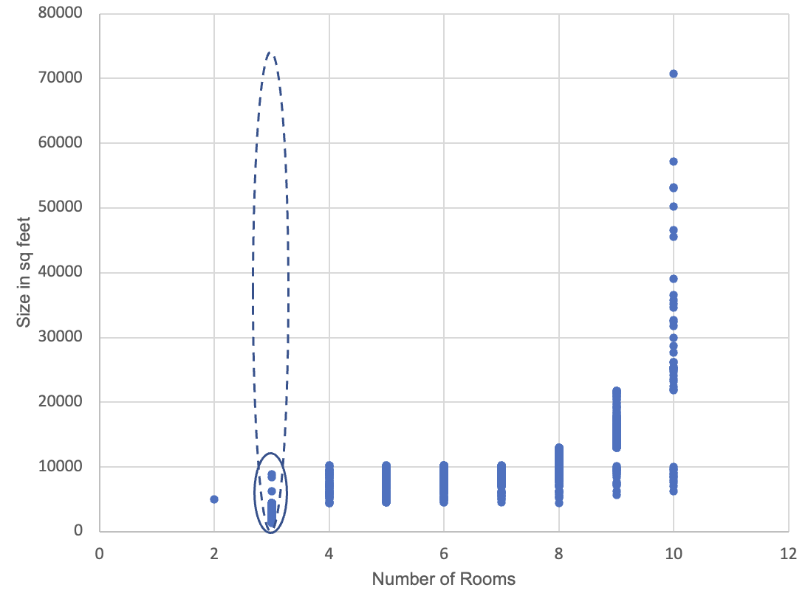
Figure 2. Issues with correlated features when calculating SHAP.
Regardless of which underlining ML model we use, during the training phase, the model will only rely on realistic pairs. Yet, when calculating the SHAP values, in order to get the marginal contributions of each feature to the prediction, we will permute each feature across their entire range (this is represented by the dotted line in Figure 2) which leads to unrealistic pairing (i.e. a 70,000 sq feet apartment with 2.5 rooms). In observational studies and machine learning problems, it is very rare that the features are statistically independent (Aas et al., 2020). This is especially the case with financial data. If there is a high degree of dependence/correlation among some or all the features, the resulting explanations might be inaccurate hence research should focus on proposing new approaches that can provide meaningful explanations even in the case in which the input space contains features that are correlated.
2.1.2.3. XAI Challenges related with phase 3: Model testing
As stated previously, the literature offers different models for obtaining explanations as to how complex models reach their decisions. Yet, studies have repeatedly found that explanations generated by attribution-based methods are not stable, i.e. infinitesimal changes to the inputs can result in substantially different explanations (Dombrowski et al., 2019, Ghorbani et al., 2019; Slack et al., 2020; Bansal et al., 2020). In addition, there has been very little effort to ensure that the explanations produced by these methods are stable and robust. Notable exceptions include Alvarez-Melis and Jaakkola (2018), Fel et al. (2021) and Agarwal et al. (2022). Alvarez-Melis and Jaakkola (2018) propose a metric for stability based on the Lipschitz continuity, a parametric notion of stability that measures relative changes in the output with respect to the input. Fel et al. (2021) in turn propose two new measures for evaluating explanations borrowed from the field of algorithmic stability: mean generalizability MeGe and relative consistency ReCo. Finally, Agerwal et al. (2022) propose a relative measure that also leverages potentially meaningful information, such as the model's internal representation, to assess stability. Although these measures can be useful, they are rarely tested on real datasets, with none of them being tested on financial data. Moreover, the existing metrics are not enabled for an intuitive understanding of stability and robustness. We argue that robustness to local perturbations of the input is a fundamental quality that explainability approaches should satisfy. In its most basic form, such a criterion means that similar units of analysis should not have explanations that are significantly different from one another (Alvarez-Melis and Jaakkola, 2018).
2.1.2.4. XAI Challenges related with phase 4: Model deployment
Another key challenge with existing XAI methods is related to the model deployment phase i.e., communicating outputs with different stakeholders. Explanations alone do not translate to understanding (Holstein et al., 2019, Bhatt et al., 2020 and Hadji Misheva et al. 2021). Successfully providing explanations regarding the inner mechanism of an algorithm and its outputs is entirely audience-dependent and the established literature fails to match the increasing number of XAI methods with the different stakeholders’ explainability needs, especially in the context of the financial sector. For the most part, existing XAI methods introduced through academic and industry efforts, aim to address the need for explainability of AI developers and engineers only (Holstein et al., 2019 and Bhatt et al., 2020). However, the value chain in the financial industry includes many stakeholders (risk experts, end users, managers, regulators, etc.), all of which might have different explainability needs (Hadji Misheva et al., 2021). The literature has made some progress in understanding the explainability needs of different stakeholder (Berg et al., 2020 and Hadji Misheva et., 2021) however, to the best of our knowledge no paper attempts to map out and match the XAI methods with the different explainability needs and thus outlining the gaps between interpretability in theory and practice. Furthermore, how explanations are presented to the different stakeholders also remains an unaddressed concern. Most existing visualizations of the explanations obtained are not intuitive nor easy to explain to a non-technical audience. Finally, most provided explanations for AI systems are typically static and carry one message per explanation (Saeed and Omlin, 2023).
2.1.3. Relevant projects currently underway in Switzerland and abroad
In recent years, there has been a growing interest in developing more interpretable and transparent models, both in Switzerland and abroad. Some of the important, relevant research projects that are currently underway in this area are:
- Graph Neural Networks for Explainable Artificial Intelligence (GraphNEx). This research is funded by the Swiss National Science Foundation (SNF) and it aims to develop a graph-based framework for developing explainable AI. Although this is tangentially linked with one of the research objectives presented in this proposal (the graph-based stability network) by relying on the same underlying idea of using concepts from graph theory in assisting explainability, the underlying concepts and approaches differ significantly. Furthermore, the active project does not focus on financial data.
- Interpretable artificial intelligence for computational biology: extracting new insights from single-cell proteomic data. This research initiative is also funded by the SNF and aims at bringing explainability to models built on single-cell mass cytometry (CyTOF) data from tumor samples. The research team in this context will similarly aim to propose novel interpretability techniques by exploiting different conceptual approaches however the application context is very different and hence not overlapping at all.
- EXPECTATION - Personalized Explainable Artificial Intelligence for decentralized agents with heterogeneous knowledge. This SNF project focuses on advancing XAI by addressing two primary challenges: (i) personalizing AI explanations to cater to diverse backgrounds and contexts, and (ii) providing explanations in decentralized environments with varied knowledge bases. This project is linked to our proposal as the researchers here also recognize the need for audience dependent explanations. Nonetheless, the running project has a much broader application touching on areas like food and nutrition monitoring and recommendation, while this proposal is specifically tailored to the finance sector. Furthermore, the projects differ significantly in the specific challenges that they address and the methodology that would be leveraged.
Center for Artificial Intelligence in Business Analytics and Financial Technology, Columbia University. The Co-PI is the director of this center which aims to collaborate closely with industry and government to drive significant change in the financial sector. The center focuses on research areas such as AI, DL, ML, Asset & Wealth Management, Data Science, Data-driven Decision Making, Financial Engineering & Algorithmic Trading, Modeling & Simulation, Operations Management, Optimization & Dynamic Pricing, and Real Estate Finance & Investment. Although the center does not currently focus on XAI explicitly, the outcomes from our project, coupled with the results from their initiatives, will be mutually beneficial.
2.2. Current state of own research
Our research team has conducted several studies and innovation and research projects in the field of interpretable and transparent AI models for financial risk assessment:
- COST FinAI. The PI and Prof. Osterrieder are heading a COST action on Fintech and AI in Finance. Collectively, this network is actively contributing and has published research on many related aspects, which we can use as foundation for our experiments/studies. Indeed, we will have access to a large pool of researchers (close to 370 researchers from 51 countries) that will directly and indirectly contribute to our research. This network will also support dissemination to the academic community.
- XAI for credit risk management. Innovation and Research Project. As part of an Innosuisse research project, the PI and Prof. Osterrieder have worked on building an open source toolkit (see https://www.explainableaiforfinance.com/) that helps users obtain some understanding of the inner-workings of AI/ML techniques applied to credit scoring. Specifically, the toolkit enables users to manipulate the input features and/or model specifications of a credit risk use case, and observe the resulting change in the outputs of the model (i.e. the predicted probabilities of default). The work conducted under this project helped the team understand in detail both the mathematical and human-centric issues of deploying explainability in practice. Moreover, by obtaining feedback from the different users of our toolkit, we uncovered that the provided explanations alone do not translate to understanding across the different users.
- Wildi, M. and Hadji Misheva, B. (2022). A Time Series Approach to Explainability for Neural Nets with Applications to Risk-Management and Fraud Detection. arXiv:2212.02906. The PI has also worked on a paper attempting to bring forward a new approach for explainability for neural nets in the specific context of applying such complex models to financial time series forecasting. In this work, we discuss yet another key issue with classic XAI methods when applied to financial use cases: their general inability to cope well with longitudinal data (time series) especially in the presence of dependence structure and non-stationarity. In order to solve these issues, we propose a generic XAI-approach for neural networks based on a family of X-functions which preserve and exploit the natural time ordering as well as the possible non-stationary dependence structure of the data. As part of the work on this paper, the research team was able to discover some of the key shortcomings of existing XAI methods when applied to financial use cases and outline the requirements of robust, forecasting-specific explainability functions. As such, the findings from these work will directly feed into the research objectives listed in this proposal.
- Hadji Misheva, B., Osterrieder, J. et al. (2021). Audience-Dependent Explanations for AI-Based Risk Management Tools: A Survey. Frontiers of AI, 4. https://doi.org/10.3389/frai.2021.794996. In this paper, members of the research team carry out a series of interviews with practitioners within the Swiss financial industry and conduct an in-depth review and discussion of their views concerning the potential and limitation of AI-based systems in financial applications. The results from this study suggests that practitioners consider two aspects key for accepting AI-based decision-making processes: (i) decisions or results of the process need to be consistent over many decision instances - over time and cross-sectionally spanning the possible parameter space, and (ii) a rationale needs to be inferable based on the process, or at least from the results of the process, that can be understood and that “makes sense” in the domain of application. In other words, the outcomes and the result of AI-based systems need to be explainable in a relevant context. These findings are pertinent as they confirm the need of context-specific explanation and a stability framework thus reinforcing the relevance of the objectives outlined in this project.
- Hadji Misheva, B., Hirsa, A., Osterrieder, J., Kulkarni, O., and Lin, S.F. (2021). Explainable AI in Credit Risk Management. arXiv:2103.00949. As preliminary work, the research team has also worked on a paper where the aim was to implement the two most advanced post-hoc, model-agnostic explainability techniques, LIME and SHAP, to ML-based credit scoring models trained on real loan performance data. We further presented multiple comparison scenarios by using various kernels available for explaining graphs generated using SHAP values. We consider this work relevant to the undertakings discussed in this proposal as it helped the research team identify the practical challenges associated with the implementation of state-of-art XAI methods and document them for future reference.
- A. Hirsa, R Ding, S Malhotra, Explainability Index (EI): Unifying Framework of Performance Measures and Risk of Target (RoT): Variability from Target EI. SSRN 4335455
The Co-PI has co-authored a paper that proposes an explainability index that offers a comprehensive evaluation of an asset or portfolio's performance by balancing various performance measures such as volatility, drawdowns, and returns. The index not only provides a composite score but also allows for component-level analysis, helping to identify the factors contributing to performance divergence when compared to targets or benchmarks. This framework is highly relevant for our proposal as it defines the starting position for XAI in asset management applications. It offers a standardized, transparent, and easily interpretable way to assess and compare financial assets or portfolios, thereby addressing the challenge of explainability in complex financial models.
2.3. Detailed research plan
2.3.1. Studies or experiments needed and/or envisaged to reach the set goals.
Generally speaking, the proposed research project will focus on addressing some of the key challenges of deploying explainability to ML and DL models applied to financial use cases. We discuss the specific studies and experiments that will help us reach the set objective under each of the four distinct phases in a ML pipeline (see Figure 1).
2.3.1.1. Data processing
Goal: measure and effectively communicate any data-related issues which might lead to inaccurate or misleading conclusions and consequently wrong explanations.
Experiments/studies. In achieving this goal, the research team will:
- Define a comprehensive fairness dimension for data quality that will be specifically tailored to the unique properties of financial data. The fairness dimension would help users identify any data issues (related with the data collection or the internal imbalances) which might reduce the accuracy when producing explanations. As stated in Das et al. (2020), currently there exists no consensus as to which of several available measures for fairness should be used in a generic manner in the different financial services industry. Hence, the research team will set out to evaluate the utility of proposed fairness measures for different financial use cases (loan origination, insurance premiums, investment advice, fraud detection, mortgage approval, marketing and recommendation) and further specify relevant and applicable data fairness and bias scores. Namely, we will: (i) define the finance use cases in which data fairness plays a key role; (ii) define the desired characteristics of a data fairness metric for the respective use cases; (iii) test and evaluate the utility of existing data fairness measure for the different finance use cases, and (iv) propose novel fairness and bias index as well as a standard operating procedure for issuing fairness certificates in financial data-driven application.
- Develop an open-source toolkit which will help end users visualize and understand data quality issues. The literature currently does not offer any practical way to communicate data quality to users (Saeed and Omlin, 2023). Although there are many open source repositories that offer visualization for various data quality issues (dlookr, fairness-comparison, AIF360, FairML, etc.), all of them require a certain level of programming skills which might not be applicable to certain finance stakeholders (end users, legal experts, etc.). In this project, we will propose a visual analytics (VA) toolkit that different audiences can use to visualize and explore the fairness dimension of different financial dataset. We aim to use RShiny for operationalizing the VA toolkit.
- Develop an open-source toolkit that will help users mitigate bias in ML models applied to financial data. In this context, it is important to mention that IBM has launched a framework, AI Fairness 360, for dealing with algorithmic bias which is open source. Although this framework can be very useful for this task, a key drawback of such context-agnostic frameworks (also including FATE by Microsoft, ML Fairness Gym by Google, Fairness Flow by Facebook, Aequitas by University of Chicago) is that they are not specifically tailored for financial data which have very different properties. Put differently, ML models/analysis is always very task-specific which in turn requires unique changes to the algorithms that are not always possible under the currently available frameworks.
2.3.1.2. Model training
Goal: propose solutions that will reduce the computational complexity of existing XAI methods, and are able to deal with the independence of features assumption.
Experiments/studies.
Scalability. The project team will work extensively on addressing the computational complexity of deploying explainability in practice by proposing and testing various solutions:
- We will test various sampling methods for the purpose of reducing the computation time. Although calculating SHAP values generally requires exponential time, the literature does offer some approaches that reduce this time. For example, TreeSHAP achieves this in polynomial time for tree-based models (Lundberg et al., 2018). Despite this considerable improvement in speed, TreeSHAP can still take significantly long time when applied on industry-level financial datasets with high dimensions (Yang, 2021). In this proposal, we will compare SHAP approximation methods based on speed, memory use and complexity as well as outline approaches that could reduce the computational time. One potential approach for reducing the number of samples fed into SHAP estimates is to leverage the concept of active learning. An active learning (AL) algorithm seeks to construct an effective classifier with a minimal number of labeled examples in a bootstrapping manner (Mondal and Ganguly, 2020). Active learning can be used for sampling by selecting the most informative samples to be labeled, thereby reducing the number of labeled samples required for training a model.
- We will investigate the possibility of parallel processing. The majority of SHAP implementations available run on single node machines, which means that they only use one core for the computations, regardless of the number of cores available (Ebrahimi and Patel, 2022). They are, therefore, constrained by the capabilities of a single core and do not benefit from distributed processing. Within this proposal, we will conduct a detailed overview of the available implementations and propose methods of how one can parallelize the explainability functions using different implementations. We would further aim to specifically pinpoint at what level of complexity, parallelization is needed and worth the effort.
- We will test different approaches of simplifying the underlying model and optimizing the computation. In developing different ML- and DL-based financial use cases, we will investigate the dependence between the underlying model architecture and the computation time for the different post-hoc explainability techniques. We will also investigate this relationship in view of the potential trade-off in accuracy that will result from the simplification of the model's architecture.
Assuming independence of features. In order to address the identified issues with XAI methods when applied on correlated inputs, the research team will introduce, compare and evaluate a variety of approaches for making explainability feasible in view of correlated features. Specifically, we will:
- Propose, test and evaluate the use of dimensionality reduction techniques. When dealing with highly correlated features, dimensionality reduction techniques like principal component analysis (PCA) or singular value decomposition (SVD) can be used to reduce the dimensionality of the data (Lever et al. 2017). This can help in reducing the number of correlated features, and can make SHAP calculations more effective. The research team will evaluate the utility of different dimensionality reduction techniques in lowering computation time and computational resource requirements in general for obtaining various local and global explanations.
- Evaluate and propose methods based on clustering techniques to reduce the effect of correlated features. The research team will propose and test cluster-based feature selection techniques to identify and manage correlated features in a dataset. The primary idea is to group features that exhibit similar patterns or relationships. By using different clustering algorithms enabled for different data types, features are grouped into clusters based on their similarity or correlation metrics. Once these clusters are formed, a representative feature is selected to represent the entire cluster. The representative feature will be selected based on its importance in the cluster, and the correlation with the target variable in the specific use case. This approach ensures that the selected features capture the essential information from the dataset while reducing multicollinearity and redundancy. As a result, the dimensionality of the dataset is reduced, leading to more efficient implementation of the XAI techniques.
- Test and evaluate the use of SHAP interaction values. Utilizing the approach proposed by Inner et al. (2021), we will quantify the dependency and interactions between features present in different financial use cases using SHAP and SHAP interaction values. Namely, given any pairs of financial features included in the different datasets, we will estimate the SHAP values across multiple observations and then decompose them into multiple sub vectors representing different types of relationships. Next, we will quantify the strength of those interactions by looking at the estimated magnitude of the vectors. With this, as described by Inner at al. (2021), we can identify three different groups of relationships: synergy, redundancy and independence. Such an approach can answer the question: Which features are fully or partially redundant with respect to the target variable in the specific financial use case, and could therefore be removed or substituted?
2.3.1.3. Model testing
Goal: propose a graph-based stability and robustness framework for post-hoc explainability methods applied to financial use cases.
Experiments/studies. Robustness intuitively means that explanations provided for a single unit of analysis should be similar to the explanations provided for the other units in its immediate vicinity. Graphs allow us to visualize such relationships and define similarity metrics hence they are perfectly positioned to address the key challenges of other existing stability measures. In order to achieve this, we would need to formalize two distance measures: (i) similarity of units of analysis (loan contracts, mortgages, financial instruments, clients, etc.) and (ii) similarity of explanations provided for those units in the specific use case. We explain our proposed approach for both measures.
- Similarity of units requiring explanations. In order to formalize this issue of which units of analysis are deemed similar, we can use different distance measures. In the case in which we use only numerical features as inputs, similarity between units can be calculated using the Euclidean, Manhattan, Minkowski or Cosine distance (Mantegna 1999, Fontes, Rodrigues, and Craig 2005, M.Merigo and Casanovas 2011, Berry, Guillen, and Zhou 2010). Alternatively, in the case in which we would like to compare units across both numerical and categorical features, distance measures suited for mixed variable types, like Gower's distance, will be used.
- Explanations' distance. In the context of the explanation distance, the research team will propose a novel approach for measuring the distance between the explanations provided for each pair of units under investigation. In the context in which SHAP is used as a method for providing the explanations, one possible approach for measuring the distance is:
$$expDis=\sqrt{\sum_{z=1}^{10}{}{{(SHAP}_{n_{zx_{i}}}-{ SHAP}_{n_{zx_{j}}})}^{2}+\sum_{z=1}^{n}{}{({SHAP}_{n_{1x_{i}}+ }{ SHAP}_{n_{zx_{j}}})}^{2}}$$
where: $n$ are the top 10 features provided by the SHAP approach, and $x_{i }$ and $x_{j }$are the different units of feature vectors, and SHAP are the specific SHAP contributions. In order words, the closer the SHAP contributions are for a pair of units, the smaller the explanation distance between them. With this measure, we can investigate the codependency between the explanation difference and the spatial difference that emerges between different units of analysis in financial use cases. We argue that an explanation metric needs to be robust in the sense that units of analysis that are similar should have similar explanations concerning the assigned output, thus we expect a divergence in the explanation similarly as the feature difference between units increases.
2.3.1.4. XAI Challenges related to phase 4: Model deployment
Goal: proposing intuitive, easy to understand, audience-dependent explanations in financial use cases.
Experiments/studies.
- Mapping out the explainability needs of different stakeholders to the existing XAI methods and in case no such tool exists, identifying the requirements of a system or a method that can bring forward the respective explanations. This step can be achieved by conducting in-depth interviews with different financial stakeholders and exploring their explainability needs within a specific finance use case as well as evaluating their level of understanding associated with existing explainability techniques. With this, we will be able to identify gaps in the literature and outline the properties of novel XAI tools which will satisfy the different explainability requirements for the different target audiences.
- Develop and launch a visual analytics tool (i.e. an open source app) which can offer a tailor interface for different audiences and thus provide different types of explanations to different stakeholders. Namely, the tool will be designed with a flexible interface that can be adjusted based on the user or stakeholder group. Stakeholders might include risk experts, ML engineers, end-users, business managers, regulators and legal experts. Each group may require different data visualizations, metrics, or explanations. Depending on the audience, the tool will provide varying types of explanations. For instance, a ML engineer might require detailed data insights including various interactive visualizations, while an end-user might get a high level, textual overview of which features have mostly resulted in the obtained output as well as what needs to change for the client to obtain a different outcome.
2.3.2. Data collection strategy
As elaborated in 2.4, in the first phase of this project, the research team will define the financial use cases that will be in the center of the research directions. In doing the selection, the research team will be guided by several principles: (i) what is the potential of ML and DL in the specific use case (use cases that can benefit more from AI-based systems, would be most in need for reliable and accurate explanations hence they would be prioritized), (ii) do we have data of sufficient quality that are readily available, and (iii) how is the use case ranked under the new EC strategy of AI (there are certain use cases that are ranked as high-risk thus in more urgent need of responsible AI). Once the financial use cases are selected, the process of data collection will start. This being said, it is important to mention that the research team has already collected and ensured access to a variety of different datasets that can be used in the project. Specifically, a key use case that could be considered is that of credit risk estimations. In this context, the team has collected and processed six distinct datasets, which are either open-source or obtained through web scraping, that contain information about the underlying loan portfolios of different P2P platforms among which Lending Club, Prosper, Mintos, Bondora, Zopa and Home Credit.
2.3.3. The role of each member of the research team
The project is a joint collaboration between two partners: Bern University of Applied Sciences (BFH) and Columbia University. On the side of Columbia University, our partner is Prof. Ali Hirsa. Prof. Hirsa is a Professor in Machine Learning and the Director of the Center for AI in Business Analytics and Fintech at Columbia University. He is also a Managing Partner at Sauma Capital, LLC a New York Hedge Fund. Prof. Hirsa's research interests are algorithmic trading, ML, DL, data mining, optimization, computational and quantitative finance. His focus has been on ML applications in finance specifically in asset management and also developing learning algorithms on signal extraction from data. Prof. Hirsa, with his extensive academic and practical experience in risk modeling and predictive analytics, will lead the model development and validation phases. Furthermore, two PhD students will be specifically hired at Columbia University to work on this project.
With a complementary skill-set and knowledge base, on the side of BFH, the project team is composed of Prof. Dr. Branka Hadji Misheva, Prof. Dr. Jörg Osterrieder, and Prof. Dr. Christian Hopp as well as two PhD students, with an additional two to be hired. Prof. Dr. Branka Hadji Misheva is an experienced team leader with multiple successful research projects. As a PI, she will be responsible for organizing work on both sides of the team while further developing, conceptualizing and designing explainability functions that are specifically tailored to financial problem sets. Furthermore, as scientific grant holder of the COST Action, FinAI, co-chair of the diversity committee, she will take responsibility for disseminating results, and organizing a research conference. Prof. Dr. Jörg Osterrieder will contribute to the research activities, the theoretical framework, and, due to his extensive experience in the industry, ensure that the use-inspired parts of the research are considered. Furthermore, as the Action Chair of the COST Action FinAI, he will take on the task of integrating and coordinating the research done under this project with that conducted within the Action. Prof. Dr. Christian Hopp is a Professor and the head of the institute for “Applied Data Science and Finance” at BFH. Prof. Hopp's hand-on experience working with financial data and ML models will be essential for spanning the bridge between the client-centric and scientific solutions. The two additional PhD students to be hired at BFH will be involved in all studies and will be selected based on their knowledge of and interest in quantitative research methods, explainable AI and mathematical optimization. Lastly, due to the integration into the COST Action FinAI, we have already received substantial interest from other leading academics to be involved in this research, e.g. from Prof. Dr. W. Härdle, HU Berlin, Prof. Dr. Codruta Mare, BBU, Cluj-Napoca, Prof. Dr. Valerio Poti, University College Dublin, Prof. Dr. Maria Iannario, University of Naples, Prof. Dr. Marcos Machado, University of Twente. Furthermore, as use-inspired project, we have not only defined the research questions in cooperation with our large practitioner network (with the aim of potentially solving practical problems) but we have also gained substantial interest from industry expects to be part of our project. Most notably, some of the interested companies are ING and LPA Group, with whom we have been cooperating for many years. In case of a successful project, we have pre-discussed ways of a technology transfer, most notably via an Innosuisse grant for our Swiss industry partners.

2.4. Schedule and milestone
The project will span four years from 2024 to 2027, with five distinct phases identified (see Table 1). In Phase I, we will define the separate financial use cases and prepare the necessary datasets. Phase II will focus on identifying the requirements of a fairness component valid across the different financial use cases identified in Phase I, and proposing ways in which this key dimension can be measured and communicated. Phase III will focus on proposing solutions that can address the two key XAI challenges related with the model training phase i.e. the computational complexity of deploying explainability in the context of high-dimensional input space, and the unsuitability of existing XAI methods under the assumption of correlated input features. Phase IV will introduce a novel graph-based, stability and robustness framework for explanations concerning the inner workings of ML and DL models applied to financial use cases. Finally, Phase V will focus on mapping the explainability needs of different finance stakeholders to specific XAI methods, and building an open source, visual analytics tool that can bring those explanations directly to the specific target audience.
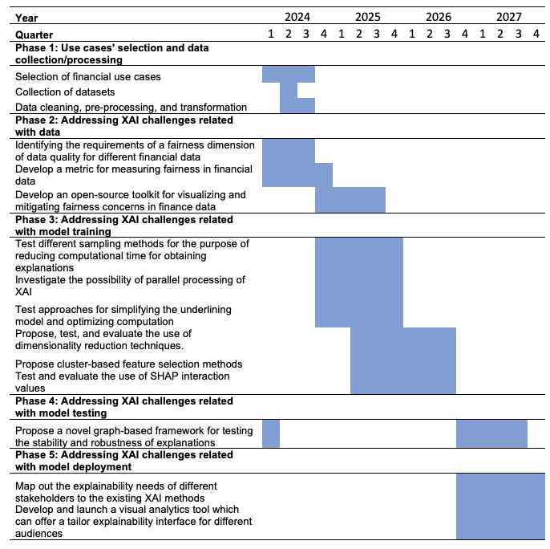
Table 1. Timeline of key activities
The expected outcomes are original research articles that will be prepared throughout the project (but starting in Phase II), presented in workshops and conferences, and submitted for publication in peer-reviewed journals. Specifically, we plan to publish 6-7 peer-reviewed publications (with impact factor) published in journals found on the Academic Journal Guide list, preferably at level 3+, e.g., Quantitative Finance, Journal of Empirical Finance, European Journal of Finance, Journal of International Financial Markets Institution and Money, International Review of Financial Analysis, Journal of Banking and Finance, Expert Systems with Applications, Economics Letters, and Annals of Operations Research. Second-tier journals for consideration are Finance Research Letters, Economic Modelling, International Review of Economics and Finance and Physica A: Statistical Mechanics with Applications.
2.5. Relevance and impact
The proposed research has several expected impacts for the discipline as a whole. Firstly, the proposed research will address the main challenges of deploying explainability in high-dimensional settings characterized with correlated inputs, thus enriching the state of the literature and at the same time, significantly expanding the applicability of existing approaches to real-world cases. Secondly, the project will lead to the introduction of novel, graph-based approaches for testing the stability and robustness of local and global explainability techniques which in turn will represent a significant contribution to the field as currently there are no comprehensive frameworks for stress-testing explanations provided by XAI methods. Thirdly, the research team will also work on mapping out the explainability needs of different financial stakeholders to specific XAI methods, thus enabling the development of a visual analytics toolkit that will allow different audiences access to the appropriate explanations. The team will prioritize the dissemination of their research results through reputable scientific journals (as elaborated in 2.4) and will actively participate in academic conferences and workshops within Switzerland and abroad.
In addition to the research results being published in scientific journals and presented at academic conferences and workshops, the research team will also collaborate with financial institutions and other stakeholders to ensure that the proposed domain-driven XAI solutions are relevant and applicable to real-world financial use cases. In addition to the existing collaborations with industry partners that have expressed interest in our project, we will aim to further expand our network by reaching out to fintech innovators, established banking institutions, and other relevant entities in the financial domain. By inviting these partners to review, test, and provide feedback on our proposed approaches, we aim to refine our solutions to meet the highest industry standards and address real-world challenges effectively. One channel for achieving this would be through the active collaboration of the team members with the data innovation alliance. The PI is the academic lead of an Expert Group on AI for finance and insurance.
From an aggregate perspective, we believe the research itself can help drive forward the application of AI-based solutions and lead to a successful digitalization of the finance industry. The greater the trust in AI, the more finance companies will deploy it; which in turn will enable them to foster innovation and move ahead in adopting next generation capabilities. For the Swiss and US financial service providers, AI is a major step forward in the digitalization and transformation of the sector and it can lead to significant efficiency gains and revenue increases. Wider adoption of AI-based solutions in finance may also lead to broad benefits for financial inclusion and financial system diversity. For example, by fully utilizing ML and DL in their risk assessment activities, banks and fintechs will be able to move some borrowers who would have been classified as subprime by traditional methods, to “better” loan grades, allowing them to get lower priced credit, thus improving financial inclusion. Moreover, the wide adoption of the AI-solutions could lead to financial system diversity thus improving the overall resilience of the financial system and ensuring financial stability.
REFERENCES:
- Agarwal, C., Johnson, N., Pawelczyk, M., Krishna, S., Saxena, E., Zitnik, M. and Lakkaraju, H. (2022). Rethinking stability for attribute-based explanations. arXiv. https://arxiv.org/pdf/2203.06877.pdf
- Ahelegbey, D.F., Giudici, P. and Hadji Misheva, B. (2019) Latent factor models for credit scoring in P2P systems. Physica A 522, pp.112-121
- Ahmed, S., Alshater, M.M., Ammari, A.E. and Hammami, H. (2022). Artificial intelligence and machine learning in finance: A bibliometric review. Research in International Business and Finance. 61. https://doi.org/10.1016/j.ribaf.2022.101646
- Alvarez-Melis, D. and Jaakkola, T.S. (2018). On the robustness of interpretability methods. arXiv. https://arxiv.org/pdf/1806.08049.pdf
- Alzahrani, R.A.; Aljabri, M. AI-Based Techniques for Ad Click Fraud Detection and Prevention: Review and Research Directions. J. Sens. Actuator Netw. 2023, 12, 4. https://doi.org/10.3390/jsan12010004
- Arrieta, Alejandro Barredo, Natalia Díaz-Rodríguez, Javier Del Ser, Adrien Bennetot, Siham Tabik, Alberto Barbado, Salvador García et al. "Explainable Artificial Intelligence (XAI): Concepts, taxonomies, opportunities and challenges toward responsible AI." Information fusion 58 (2020): 82-115.
- Artificial Intelligence (AI) Market - Global Industry Analysis, Size, Share, Growth, Trends, Regional Outlook, and Forecast 2022 – 2030. (2022). Precedence Research. https://www.precedenceresearch.com/artificial-intelligence-market
- Aslam, F., Hunjra, A.I., Ftiti, Z., Louhichi, W. and Shams, T. (2022). Insurance fraud detection: Evidence from artificial intelligence and machine learning, Research in International Business and Finance, 62 https://doi.org/10.1016/j.ribaf.2022.101744.
- Athey, S. (2019). The impact of machine learning on economics. In A. Agrawal, J. Gans, & A. Goldfarb (Eds.), The economics of artificial intelligence: An Agenda (pp. 507–547). University of Chicago Press. [Crossref], [Google Scholar]
- Bansal Naman, Agarwal Chirag, Nguyen Anh. Sam: The sensitivity of attribution methods to hyperparameters // CVPR. 2020
- Bazarbash, M. (2019). FinTech in financial inclusion: Machine learning applications in assessing credit risk (IMF Working Paper No. 19-109). Washington, D.C.: International Monetary Fund. [Google Scholar]
- Bhattacharya, C and Sinha, M. (2022). The Role of Artificial Intelligence in Banking for Leveraging Customer Experience, Australasian Accounting, Business and Finance Journal, 16(5), 2022, 89-105. doi:10.14453/aabfj.v16i5.07
- Cascarino, G., Miscatelli, M. and Parlapiano, F. (2022). Explainable Artificial Intelligence: Interpreting Default Forecasting Models Based on Machine Learning. SSRN.
- Danielsson, J., Macrae, R. and Uthemann, A. (2022). Artificial Intelligence and systemic risk. Journal of Banking and Finance. 140. https://doi.org/10.1016/j.jbankfin.2021.106290
- Das, S., Donini, M., Gelman, J., Haas, K., Hardt, M., Katzman, J., Kenthapadi, K., Larroy, P., Yilmaz, P. and Zafar, B. (2020). Fairness Measures for Machine Learning in Finance. https://pages.awscloud.com/rs/112-TZM-766/images/Fairness.Measures.for.Machine.Learning.in.Finance.pdf
- Dombrowski Ann-Kathrin, Alber Maximilian, Anders Christopher J, Ackermann Marcel, Muller Klaus-Robert, Kessel ¨ Pan. Explanations can be manipulated and geometry is to blame // arXiv. 2019.
- Doshi-Velez, F., Kim, B. (2017). Towards a rigorous science of interpretable machine learning. arXiv preprint arXiv:1702.08608.
- Dubey, S.R., Singh, S.K. and Chaudhuri, B.B. (2022). Activation functions in deep learning: A comprehensive survey and benchmark. Neurocomputing, 503(7). https://doi.org/10.1016/j.neucom.2022.06.111
- Ebrahimi, S. and Patel, P. (2022). Scaling SHAP Calculations With PySpark and Pandas UDF. Databricks.
- Explainable AI: The basics. (2019). The royal society. Policy briefing. https://royalsociety.org/-/media/policy/projects/explainable-ai/AI-and-interpretability-policy-briefing.pdf
- Fan, Z., Fang, H., Zhou, Z., Pei, J., Friedlander, M.P., Liu. C. and Zhang, Y. (2022). Improving Fairness for Data Valuation in Horizontal Federated Learning. IEEE 38th International Conference on Data Engineering (ICDE)
- Fel, T., Vigouroux, D., Cadene, R. and Serre, T. (2021). How good is your explanation? Algorithmic Stability Measures to Assess the Quality of Explanations for Deep Neural Networks. arXiv. https://arxiv.org/pdf/2009.04521.pdf
- Ghorbani Amirata, Abid Abubakar, Zou James. Interpretation of neural networks is fragile // AAAI. 2019.
- Giudici, P., Hadji Misheva, B. and Spelta, A. (2019a). Network-based risk models. Quality Engineering 32(2), 199-211
- Giudici, P., Hadji Misheva, B. and Spelta, A. (2019b). Network scoring models to improve credit risk management in P2P lending platforms. Frontiers in Arti cial Intelligence, 2, pp.3-9
- Gupta, N., Patel, H., Afzal, S., Panwar, N., Mittal, R.S., Guttula, S., Jain, A., Nagalapatti, L., Metha, S., Hans, S., Lohia, P., Aggarwal, A. and Saha, D. (2021). Data Quality Toolkit: Automatic assessment of data quality and remediation for machine learning datasets. IBM research group. arXiv. https://arxiv.org/pdf/2108.05935.pdf
- Hadji Misheva, B., Hirsa, A. and Osterrieder, J. and Kulkarni, O. and Fung Lin, S. (2021) Explainable AI in Credit Risk Management (March 1, 2021). Available at SSRN: https://ssrn.com/abstract=3795322 or http://dx.doi.org/10.2139/ssrn.3795322
- Hadji Misheva, B., Jaggi, D., Posth, J. Osterrieder, J. and Gramespacher, T. (2021). Audience-dependent Explanations for AI-based Risk Management Tools: A Survey. Accepted in Frontiers of AI: Explainable, Trustworthy, and Responsible AI for the Financial Service Industry.
- Haselbeck, F., Killinger, J., Menrad, K., Hannus, T. and Grimm, D.G. (2022). machine learning (ML) and deep learning (DL) models started to outperform classical methods in applied use cases and forecasting competitions. Machine learning with applications, https://doi.org/10.1016/j.mlwa.2021.1002397(15).
- Hentzen, J.K., Hoffmann, A., Dolan, R. and Pala, E. (2021). Artificial intelligence in customer-facing financial services: a systematic literature review and agenda for future research. International Journal of Bank Marketing. 10.1108/IJBM-09-2021-0417
- Holzinger, A., Saranti, A., Molnar, C., Biecek, P. and Samek, W. (2022). Explainable AI Methods - A Brief Overview. Part of the Lecture Notes in Computer Science book series (LNAI,volume 13200). https://link.springer.com/chapter/10.1007/978-3-031-04083-2_2#Fig2
- Ittner, J., Bolikowski, L., Hemker, K., & Kennedy, R. (2021). Feature Synergy, Redundancy, and Independence in Global Model Explanations using SHAP Vector Decomposition. arXiv preprint arXiv:2107.12436.
- Kauffmann, J., Esders, M., Montavon, G., Samek, W., Müller, K.R.: From clustering to cluster explanations via neural networks. arXiv preprint arXiv:1906.07633 (2019)
- Kole, S., Bruna, J., Kutyniok, G., Levie, R., Nguyen, D.A.: A rate-distortion framework for explaining neural network decisions. In: Holzinger, A., et al. (eds.) xxAI 2020. LNAI, vol. 13200, pp. 91–115. Springer, Cham (2022)
- Krishna, S., Han, T., Gu, A., Pombra, J., Jabbari, S., Wu, Z.S. and Lakkaraju, H. (2022). The disagreement problem in explainable machine learning: A practitioner's perspective, arXiv. https://arxiv.org/pdf/2202.01602.pdf
- Kumar, E., Venkatasubramanian, S., Scheidegger, C. and Friedler, S.A. (2020). Problems with Shapley-value-based explanations as feature importance measures. arXiv. https://arxiv.org/pdf/2002.11097.pdf
- Linardatos, Pantelis, Vasilis Papastefanopoulos, and Sotiris Kotsiantis. 2021. "Explainable AI: A Review of Machine Learning Interpretability Methods" Entropy 23, no. 1: 18. https://doi.org/10.3390/e23010018
- Longbing, C. (2022). AI in Finance: Challenges, Techniques, and Opportunities. ACM Computing Surveys. 55(3). https://doi.org/10.1145/3502289
- Lundberg, S.M., Erion, G.G., Lee, S.I.: Consistent individualized feature attribution for tree ensembles. arXiv preprint arXiv:1802.03888 (2018)
- Lundberg, S.M., et al.: From local explanations to global understanding with explainable AI for trees. Nat. Mach. Intell. 2(1), 56–67 (2020)
- Lundberg, S.M., Lee, S.I.: A unified approach to interpreting model predictions. In: Advances in Neural Information Processing Systems, vol. 30, pp. 4765–4774 (2017)
- Luo, D., et al.: Parameterized explainer for graph neural network. In: Advances in Neural Information Processing Systems, vol. 33, pp. 19620–19631 (2020)
- Mahanti, R. (2019). Data Quality: Dimensions, Measurement, Strategy, Management, and Governance. ASQ Quality Press.
- Maksymiuk, S., Gosiewska, A., and Biecek, P. (2020). Landscape of R packages for eXplainable Artificial Intelligence. arXiv preprint arXiv:2009.13248, 2020
- Miller, T. (2018). Explanation in Artificial Intelligence: Insights from the Social Sciences, arXiv:1706.07269v3.
- Mittelstadt, B.: Principles alone cannot guarantee ethical AI. Nat. Mach. Intell. 1, 1–7 (2019)
- Molnar, C., (2019). Interpretable machine learning, https://christophm.github.io/interpretable-ml-book/
- Mondal, I., & Ganguly, D. (2020). ALEX: Active Learning based Enhancement of a Model's Explainability. arXiv preprint arXiv:2009.00859.
- Montavon, G., Kauffmann, J., Samek, W., Müller, K.R.: Explaining the predictions of unsupervised learning models. In: Holzinger, A., et al. (eds.) xxAI 2020. LNAI, vol. 13200, pp. 117–138. Springer, Cham (2022)
- Montavon, G., Lapuschkin, S., Binder, A., Samek, W., Müller, K.R.: Explaining nonlinear classification decisions with deep Taylor decomposition. Pattern Recogn. 65, 211–222 (2017)
- Montavon, G., Samek, W., Müller, K.R.: Methods for interpreting and understanding deep neural networks. Digit. Signal Process. 73, 1–15 (2018)
- Moscatelli, M., Narizzano, S., Parlapiano, F., Viggiano, G. (2019). Corporate default forecasting with machine learning (No. 1256). Bank of Italy, Economic Research and International Relations Area
- O’Sullivan, S., et al.: Legal, regulatory, and ethical frameworks for development of standards in artificial intelligence (AI) and autonomous robotic surgery. Int. J. Med. Robot. Comput. Assisted Surg. 15(1), e1968 (2019)
- Pearl, J.: The seven tools of causal inference, with reflections on machine learning. Commun. ACM 62(3), 54–60 (2019)
- Pitoura, E. (2020). Social-minded Measures of Data Quality: Fairness, Diversity, and Lack of Bias. Journal of Data and Information Quality. 12(3). https://doi.org/10.1145/3404193
- Reiter E. (2019) Proceedings of the 1st Workshop on Interactive Natural Language Technology for Explainable Artificial Intelligence, NL4XAI, Association for Computational Linguistics (2019), pp. 3-7, 10.18653/v1/W19-8402
- Revenues from the artificial intelligence (AI) software market worldwide from 2018 to 2025. (2023).Statista. https://www.statista.com/statistics/607716/worldwide-artificial-intelligence-market-revenues/
- Ribeiro, M.T., Singh, S., Guestrin, C.: Anchors: high-precision model-agnostic explanations. In: Proceedings of the AAAI Conference on Artificial Intelligence, vol. 32, no. 1 (2018)
- Ribeiro, M.T., Singh, S., Guestrin, C.: Why should I trust you?: explaining the predictions of any classifier. In: 22nd ACM SIGKDD International Conference on Knowledge Discovery and Data Mining (KDD 2016), pp. 1135–1144. ACM (2016)
- Sadok, H., Sakka, F. and Maknouzi, M.E. (2022). Artificial intelligence and bank credit analysis: A review. Cogent Economics & Finance, 10, 1. https://doi.org/10.1080/23322039.2021.2023262
- Saeed, W. and Omlin, C. (2023). Explainable AI (XAI): A systematic meta-survey of current challenges and future opportunities. Knowledge-based systems, 263. 110273. https://doi.org/10.1016/j.knosys.2023.110273
- Samek, W., Montavon, G., Lapuschkin, S., Anders, C.J., Muller, K.-R., 2021. Explaining deep neural networks and beyond: a review of methods and applications. Proc. IEEE 109 (3), 247–278. https://doi.org/10.1109/PROC.510.1109/JPROC.2021.3060483
- Slack Dylan, Hilgard Sophie, Jia Emily, Singh Sameer, Lakkaraju Himabindu. How can we fool LIME and SHAP? Adversarial Attacks on Post hoc Explanation Methods // AIES. 2020
- Spyros Makridakis, Evangelos Spiliotis, and Vassilios Assimakopoulos. The m4 competition: 100,000 time series and 61 forecasting methods. International Journal of Forecasting, 36(1):54–74, 2020. M4 Competition.
- Spyros Makridakis, Evangelos Spiliotis, and Vassilios Assimakopoulos. The m5 competition: Background, organization, and implementation. International Journal of Forecasting, 2021.
- Transforming paradigms. A global AI in Financial Services Survey. (2020). World Economic Forum. Cambridge Center for Alternative Finance. https://www3.weforum.org/docs/WEF_AI_in_Financial_Services_Survey.pdf
- Wildi, M. and Hadji Misheva, B. (2022). A Time Series Approach to Explainability for Neural Nets with Applications to Risk-Management and Fraud Detection. Working Paper.
- Yang, J. (2022). Fast TreeSHAP: Accelerating SHAP Value Computation for Trees. arXiv preprint arXiv:2109.09847.

EU AI Act

